Case 6-Afr-Mauritania-Dakhlet Region-Root Digging Annular Disk-Basalt-6-4 kya
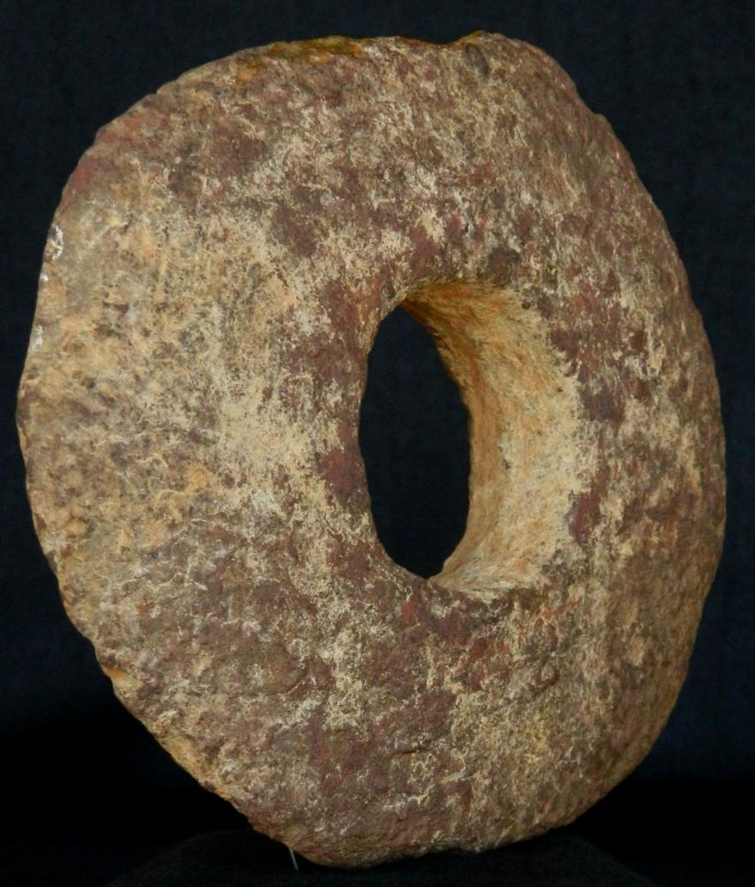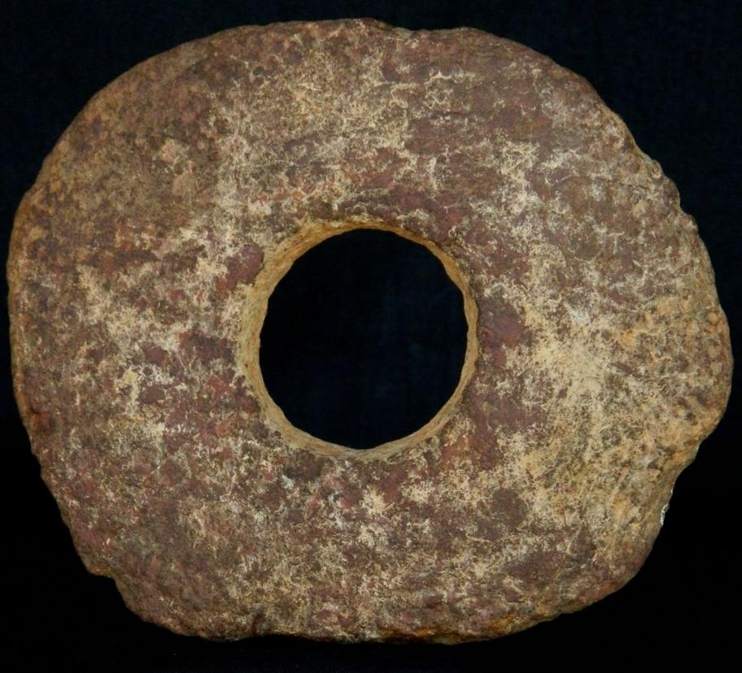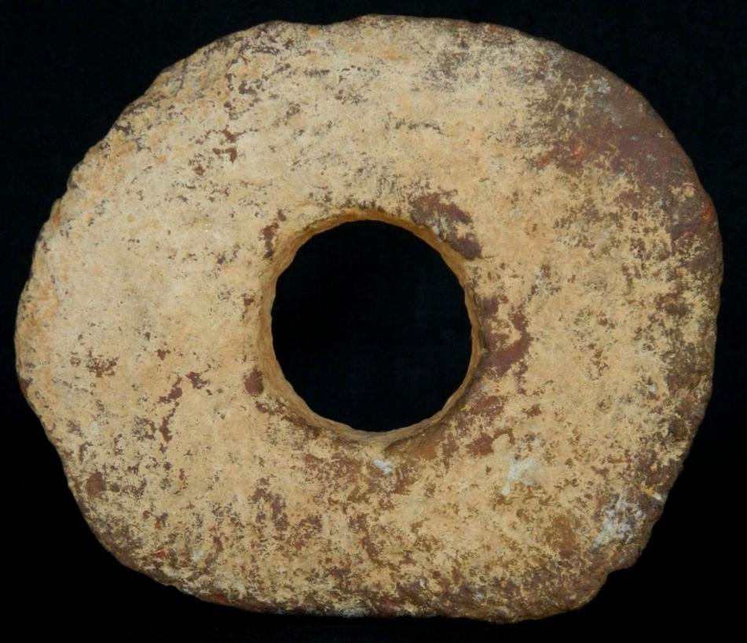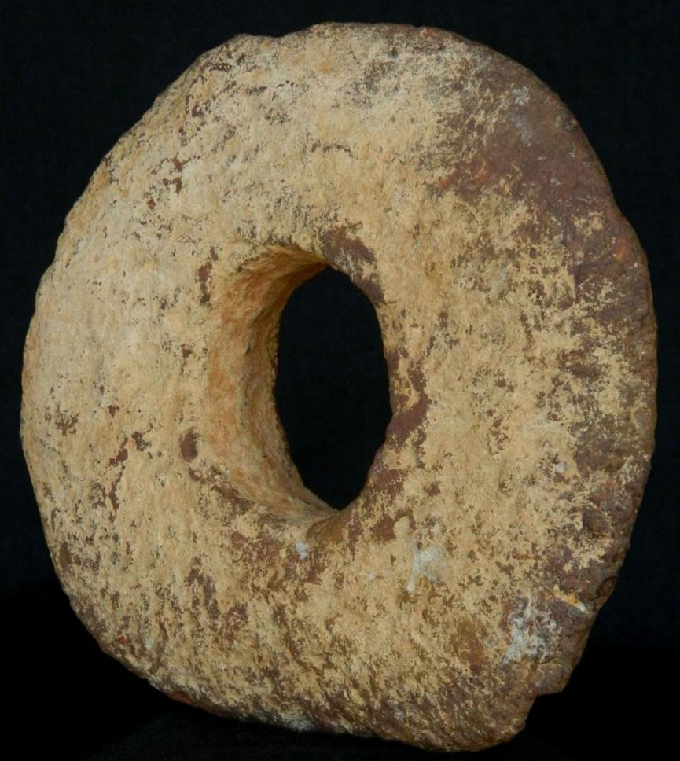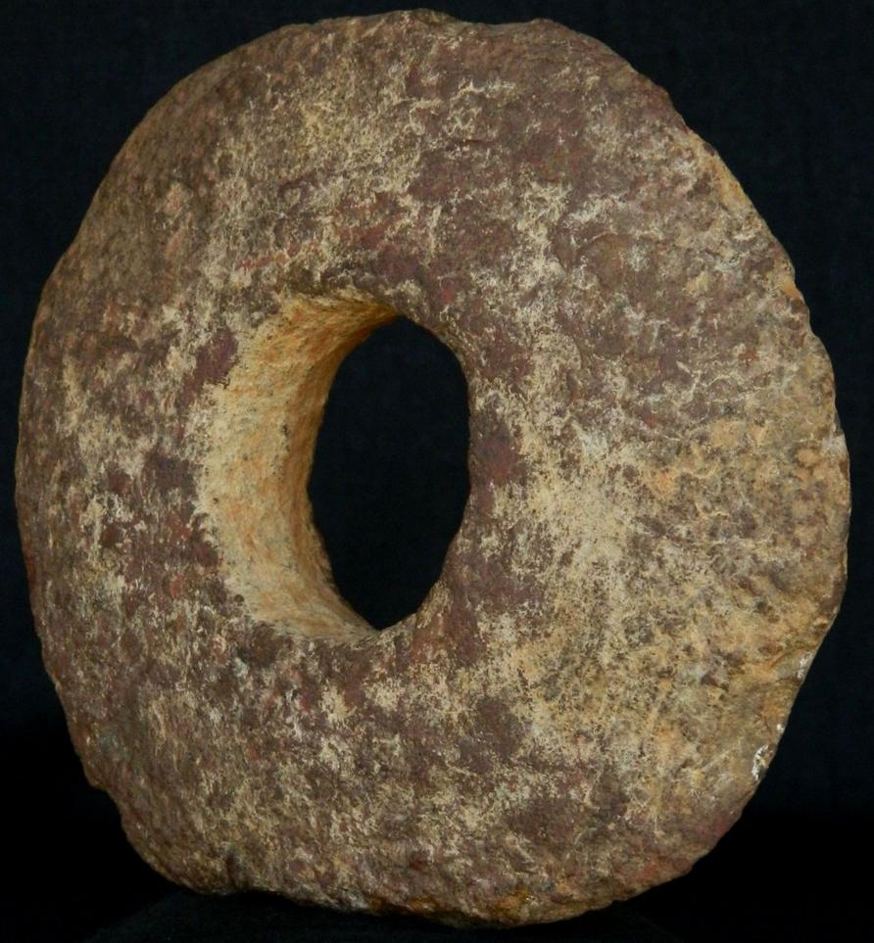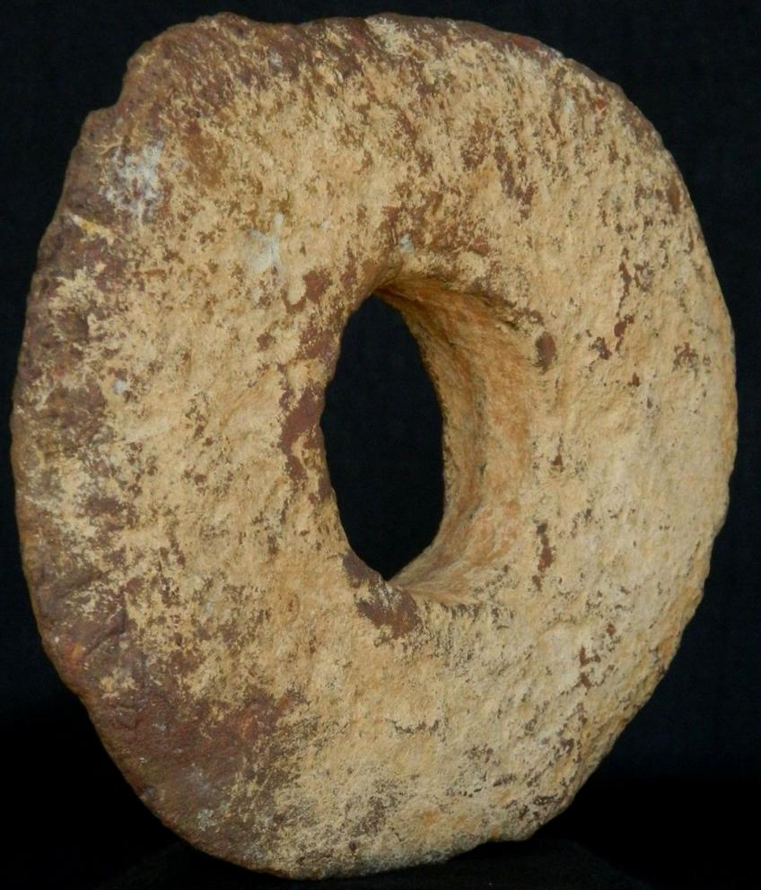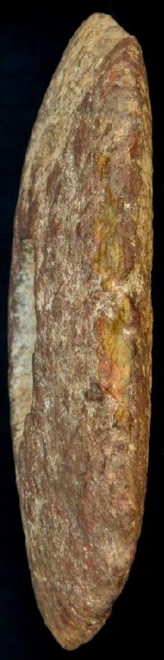
Neolithic basalt annular disc- 14 cm / 5.5"- 6000 to 3000 years BP-from the Dakhlet region, in the Sahara region of Northern Mauritania
Digging sticks were fitted into the hole to increase the fulcrum when digging for tubers.

Sales order
Sold by kyramint2001 ( 1825 )
+ Show additional actions

Delivery package 1 of 1
Estimated delivery Tuesday, Jun 14, 2016 - Thursday, Jun 30, 2016
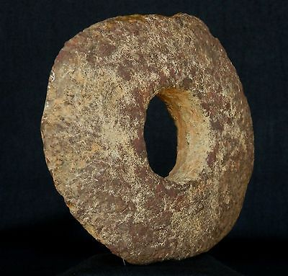

Neolithic Basalt Annular Disc - 14 cm / 5.5"- 6000 to 3000 years BP - Sahara
Item price | $60.00
Quantity | 1
Item number | 301954194597
Shipping service | Economy Shipping from outside US
Contact seller
Return item

Shipping address

Ralph J Coffman Jr
149 Atlantic Ave
Swampscott MA 01907-2427
United States

Order total

Subtotal | $60.00
Shipping | $11.95
Total
$71.95
View PayPal transaction

Order placed on
Wednesday, May 25, 2016
Payment method
PayPal
Payment date

